Soal Praktikum  Practicum Case | 
Z1451
Jaringan Komputer
Sistem Komputer  Computer Engineering | O1-Z1451-HP01
Periode Berlaku Semester Ganjil 2015/2016  Valid on Odd Semester Year 2015/2016 | Revisi 00  Revision 00

Learning Outcomes
- Explain fundamentals of computer communications and network architecture

Topic
- Session 01 - Computer Network Introduction

Sub Topics
- Introduction to Packet Tracer
- Network Devices
- Crimping Cables
- Network Devices
- Network Topology
- OSI 7 Layer
- Peer to Peer Examples

Soal
Case

- Computer network is a system that consists of computer and other network devices which work together to achieve the same purpose.
Computer network purpose is described as follows:
- Sharing resources
Example: sharing printer, CPU, memory, hard disk users.
- Communication
Example: email, instant messaging, and chatting.
- Information access
Example: web browsing.

- Based on network topology, computer network can be grouped into some section that described as follows:
- Bus topology
Bus topology used “single backbone segment” as a connector for all computer in the network. All computers directly connected with each other computer.
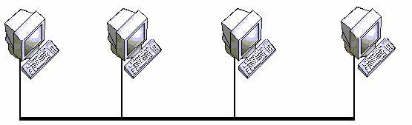
- Star topology
Star topology connecting all workstation to one central point. The central can be a hub or switch, as if all connected computer formed like as a star.

- Extended star topology
Extended star topology is a combination of some star topology that connected each other.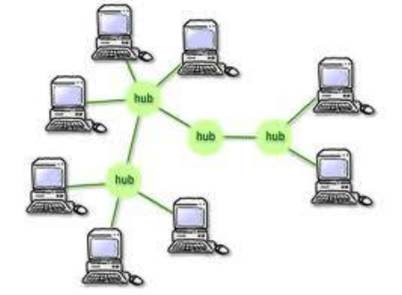
- Ring topology
Ring topology has the form of workstation sequence which each other connected to two others workstation, so that formed a circular circuit as a ring. In this ring topology, data communication can be interfere when one point of them had a problem.
- Mesh topology
Mesh topology has the form of connection between devices, where each device directly connected to others device in a network. Therefore, in this topology each devices can be directly communicating with destination device (dedicated links). Mesh topology is used when miscommunication in a network cannot be tolerated, for the example is a nuclear power plant control system.
- Tree topology
This network topology can be called as a multilevel network topology. This topology to be used for interconnection between central with other hierarchy. For low level hierarchy can be described at lower location and high level hierarchy have higher location. This network topology types is suitable for computer network system.
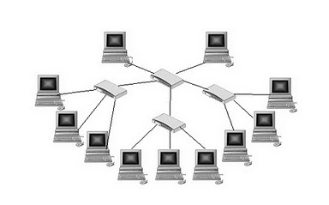

- Example of computer network devices:
- Hub
A device that can connect some computers to one network. Usually were grouped based on port number. Support UTP transmission media. Hub contains signal amplifier, so that it can reached device at range 100 meter from hub and sending back with the same range.
All transmissions that entered the hub will be sent back to all connected devices in its port to be processed again by each devices. Transfer speed in hub is divided between connected devices, so that if more port had been used then hub speed will be slow down.
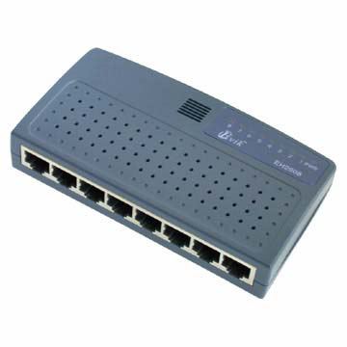

- Switch
Switch is very similar with hub, but both are different. In switch, packet allowed based on MAC address on MAC Address table at switch. Work on layer 2 in OSI model.
How the switch work:
- When the packet received by bridge, the packet will be checked whether its destination MAC address is connected to the same port with sender’s MAC address.
- If its on the same port then the packet will not be forwarded to another port.
- If not, then the packet will be forwarded to the network port that contain destination MAC address.
- As the result logical circuit has been formed in switch between communicating two networks, so that others network isn’t disturbed. Therefore, in switch speed is not shared, but each port has full bandwidth so transfer dataspeed will be greater than switch.
There are 2 types of switch: Unmanageable switch and Manageable switch. Unmanageable switch similarly with hub but much faster and data only sent to port that have destination network. Manageable switch have addtional feature that can create Virtual LAN with configure the switch, so that it can manage the data transmission and only from and to specified network.
- Router
Router is a network device that operates in OSI 3 layer (network layer). Some router merged, connecting some network segments or all of the network. Router sent data based on information on layer 3.

- Crimping cable experiment
- Prepare all needed tools:
- Crimping tool

- UTP cable (Unshielded Twisted Pair)
- RJ-45
- Peeled tip of UTP cable using crimping tool.
- Arrange the color based on cable types:
- Straight Cable
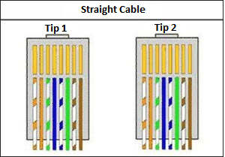
Tip 1 Standard:
- Pin 1 White – Orange
- Pin 2 Orange
- Pin 3 White – Green
- Pin 4 Blue
- Pin 5 Blue – White
- Pin 6 Green
- Pin 7 White – Brown
- Pin 8 Brown
Tip 2 Standard:
- Pin 1 White – Orange
- Pin 2 Orange
- Pin 3 White – Green
- Pin 4 Blue
- Pin 5 Blue – White
- Pin 6 Green
- Pin 7 White – Brown
- Pin 8 Brown

- Cross Cable
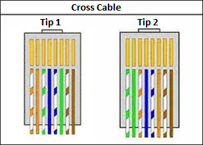
Tip 1 Standard:
- Pin 1 White – Orange
- Pin 2 Orange
- Pin 3 White – Green
- Pin 4 Blue
- Pin 5 Blue – White
- Pin 6 Green
- Pin 7 White – Brown
- Pin 8 Brown
Tip 2 Cross:
- Pin 1 White – Green
- Pin 2 Green
- Pin 3 White – Orange
- Pin 4 Blue
- Pin 5 Blue – White
- Pin 6 Orange
- Pin 7 White – Brown
- Pin 8 Brown
- Cut the cable neatly by using crimping tool.
- Put the cable to RJ-45 connector until tip of cable seen on head of RJ-45 connector.
- Lock the RJ-45 cable by putting it on crimping tool for pressing, to completely attached on RJ-45 connector.
- Test the cable by plugging in the cable to computer.
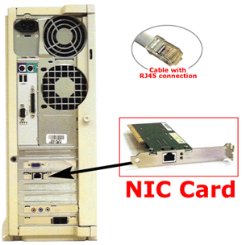
- To test the cable, try connecting 2 computers with LAN cable that already created, after that try use syntax ping <ip address computer>
Example:
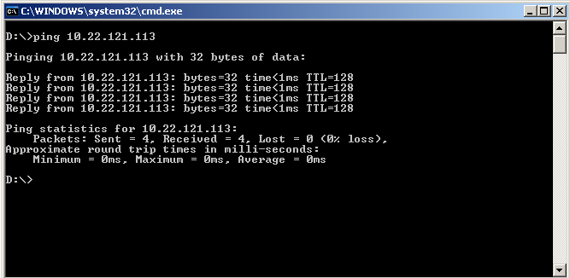
- To get the ip address from a computer, use the syntax IPCONFIG on cmd
Ethernet adapter Local Area Connection:
Connection-specific DNS Suffix:
IP Address. . . . . . . . . . . . . . : 10.22.121.113
Subnet Mask . . . . . . . . . . . . : 255.255.255.0
Default Gateway . . . . . . . . . : 10.22.121.1

- Packet Tracer
Packet Tracer was a software that known as Cisco Packet Tracer to create simulation of networking design or process.
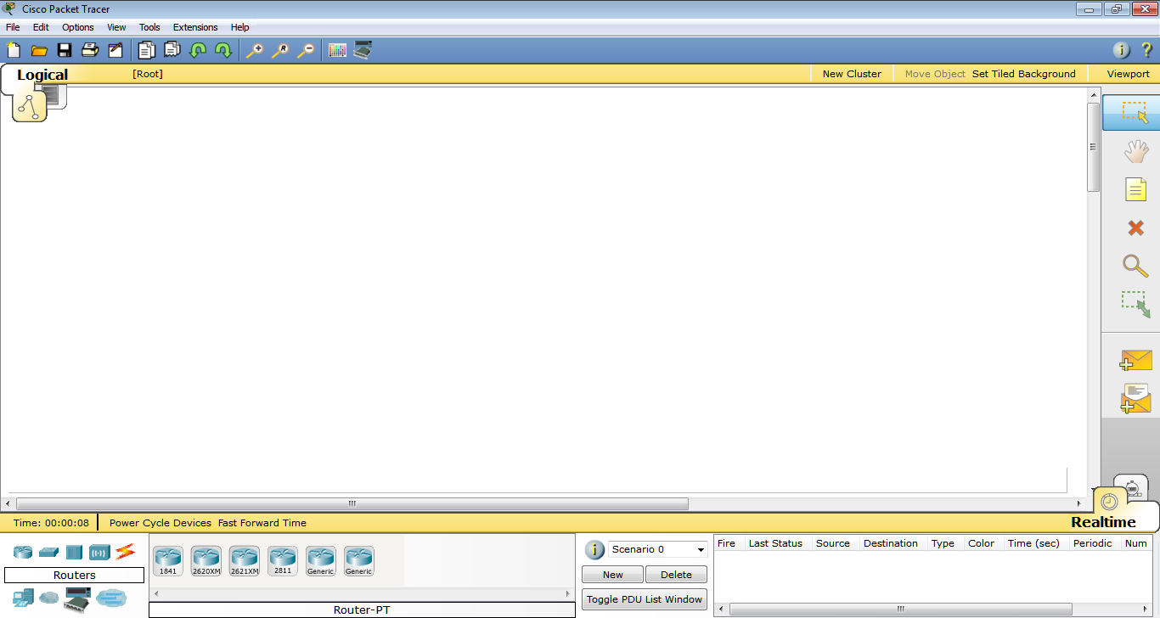
Cisco Packet Tracer New Project Interface
For the network devices have some symbol, here are the details:
Symbol | Name | Description
 | Router | used to forwards data packets from same or different networks segment
 | Switch | used to forwards data packets only for the receiver device from same network segment
 | Hub | used to forwards data packets only for the receiver device from same network segment
 | Wireless Devices | used to configure wireless or not wired device connection
 | Cable Connection | used to connecting other device based on device types
 | End Devices | used to connecting wired device connection
 | WAN Emulation | used to emulate the wide area network model
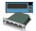 | Custom Devices | used to customize network device, such as ports or interfaces
 | Multiuser Connection | used to create remote connection

If you don’t understand, please ask your assistant!

